It is rare to find someone in today’s society that doesn’t have a Facebook account. The website has completely revolutionized the way people keep in contact with others. When you create a Facebook account, it states “By clicking Sign Up, you agree to our Terms, Data Policy and Cookie Policy.” And links to the 3 terms of service. These include thousands of words describing the types of information Facebook can legally collect and store about you.

You can request Facebook to create a collection of all the information the website has about you. You can then download a zip file containing the information and can see it organized into different folders for categories like messages, pages, and search history. The folder I downloaded about my data was 3.47GB. There are currently around 2.4 billion monthly active Facebook users, each who have accepted the terms of service to collect their data, so there will an unimaginable amount of information stored about people around the world. The folders contain files showing all of the specific information Facebook has about you:



This image shows the HTML page showing my location history of when I used Facebook:

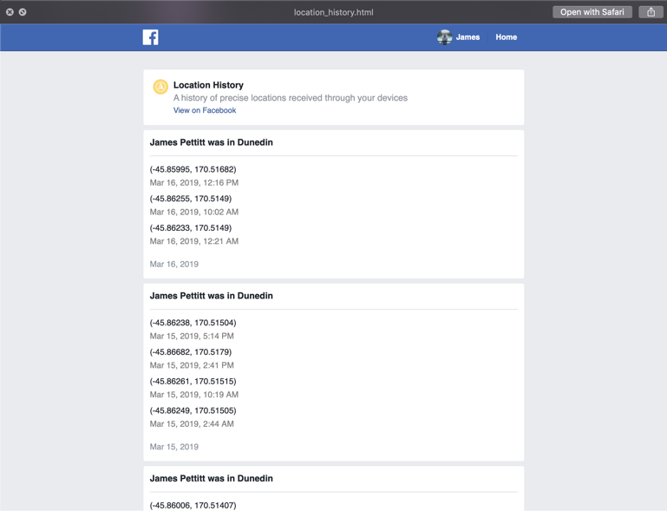

When I opened this zip file and looked through it, I was very shocked at how much information Facebook had about me. We become so used to accepting terms of service on websites, that I have never stopped to think about just how much information I am letting websites store about me. The location_history.html folder in particular shocked me a lot, as it has my GPS coordinates of every time that I have used the Facebook application on my phone, or the website on my laptop. I have no problem with my location data being collected, as I believe they use to ensure my account is secure. For example, when I travelled to England recently, when I logged into my Facebook account on a family member’s laptop, I instantly got a notification on my phone warning me of this suspicious activity. “Your account was recently logged into by a device in Birmingham, England. Was this you?” is what showed on my screen. It also showed the IP address and name of the device. I was impressed that Facebook had gone to this level to ensure the privacy of my account.

Facebook claims they use the data they store about us to create systems that they use to allow for fast and effective communication and updates on people’s life. An example of a system that Facebook has created to use its mass number of users to help people is the Crisis Response system during a natural or man-made disaster. Upon news of a nearby incident, you can ‘check-in’ to instantly give all of your friends a notification to let them know you have avoided the disaster and are away from harm. This determines whether people in the affected geographical location are safe. The following screenshot taken from Facebook’s website describes the purposes of their Crisis Response system:



There is no doubt that Facebook collects a lot of information on each of its users. The question of whether or not this is ethical of Facebook to collect has been debated for over a decade. The issue that I have with Facebook is how they give that data to application developers.

It has been widely reported in the media that Facebook did a very bad job of enforcing application developers to obey rules around data storage and privacy. Developers have been outed for keeping data longer than they needed to, to track trends and create analytics to assumedly increase their profits. They have also been known to not delete this stored data when requested by Facebook or the government. Facebook was accused of knowing all of this information and not reporting or acknowledging it until they were accused in court.

Application developers know that if they can get Facebook to integrate their app, users will be a lot more likely to use it. When you click a link on a website to do a quiz or survey or play a game, and it asks you to ‘Sign in with Facebook’, this is an example of a Facebook-integrated application. Facebook did not make this app and it does not monitor it, but by using Facebook to sign in, you find it more trustworthy and allow them to access all of your data through Facebook. You may be able to choose which data applications can access, but developers are smart and will be able to find their way around such barriers. Having third-party application access my data is where I have a problem.

Another problem I have is with Facebook selling information to other companies, that can use it to politically manipulate me to vote a certain way, or commercially manipulate me to show me products it assumes I want to see, and am therefore more likely to give money to that company. An example of the extent of this manipulation is companies targeting ads towards us to get us into specific moods. For example, if a company can track our data enough that it knows when we are in a sad mood, we spend lots of money, it could track our messages to notice when we are sad and target ads towards us to make us sadder. This will make us more likely to spend money, and they can then give us ads for things we’ve been talking about, so we buy them. This is why I do not agree with Facebook collecting this data.